BIOLUMINESCENCE KAYAK TOUR (Titusville)
Saturday, 9/8/18 7:45 PM - approx. 9:45 PM
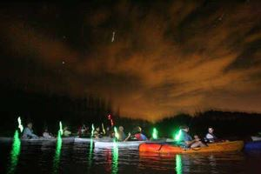
Join us for an unforgettable evening of kayaking in the bioluminescent glow (a natural phenomenon of glowing blue, alive with activity). The swirling of your hand, every paddle stroke and the rolling wake off of your kayak all glow in the darkness like an under-water laser light show. Fish leave trails, dolphins look like torpedoes, and manatees a slow and graceful submarine.
For those interested we’ll meet at Dixie Crossroads at 5:30 for dinner (at your own expense). All paddlers will assemble at 7:45 PM at Beacon 42 launch point (subject to change). We’ll be paddling with A Day Away Kayak outfitters. Day Away will have guides there to provide instruction and lead us on our adventure (no experience necessary). We’ll spend about 1½ hours on the water.
For more information, see: https://www.adayawaykayaktours.com/webapp/p/325/bioluminescence-tours

$50.00 per person (2 paddlers per kayak) Includes tax and gratuity
Bring Water Shoes, Towels, Snacks, Quick Dry Clothes and Bug Spray
Sign ups will be available on OSTC website soon!
Event leader: Steve Sovich
OSCStevo@gmail.com
407-929-0132

